Requirements of quick bites

1.user registration and login
2.list of restaurants
3.shows nearby restaurants
4.offers
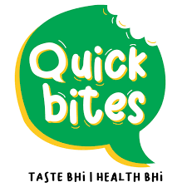
5.search functions
6.filtering
7.restaurant details
8.food menu
9.cart
10.payment
10.1 online payment
10.2 cash on delivery
11.rewards for order
12.order tracking
13.notification
14.ratings and reviews
15.advertisment generation
16.separate app for partners
17.customer care
Ashna sanah safna parvathy Naveen anish

